TCS3351 CRYPTOGRAPHY AND DATA SECURITY
TUTORIAL 2

MATHEMATICAL BACKGROUND – I

- a) Which of the following relations are true and which are false?
(i) $5 |$ 26 (ii)$3 | 123$ (iii) $27 ∤127$ (iv)$15∤21$

b) Find the results of the following operations.
(i) -78 mod 13 (ii) 0 mod 13 (iii) 150 mod 15 (iv) -66 mod 33

- a) Using the Euclidean algorithm, find the greatest common divisor of the pairs on
integers, 88 and 220.
- Using the extended Euclidean algorithm, find the greatest common divisor of the pairs (4,7) and the value of s and t.

- Perform the following operations using reduction first.
(i) (4223 +17323) mod 10
(ii) (2468 – 43) mod 15
(iii) (144 ×34) mod 12
(iv) (221 × 23) mod 22

- Check whether the multiplicative inverse exists for each of the following integers and if exists, find it using the extended Euclidean algorithm.
(i) 61 in Z₉₀ (ii) 132 in Z₁₈₀

- Let us assign numeric values to the uppercase alphabet (A=0, B=1, …, Z=25). Answer the following using modulo 26.
  - (A+N) mod 26 (ii) (A+6) mod 26
  - (Y-5) mod 26 (iv) (C-10) mod 26

References:

- Behrouz A. Forouzan, Debdeep Mukhopadhyay, "Cryptography and Network Security", Third Edition, McGraw-Hill, 2015.

- William Stallings, “Cryptography and Network Security – Principles and Practice”, Seventh Edition, Prentice Hall, 2017.

Extra Exercises:

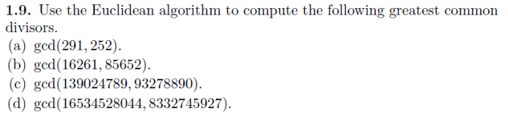

References:
- Jeffrey Hoffstein, Jill Pipher and Joseph H. Silverman, “An Introduction to Mathematica; Cryptography”, Second Edition, Springer, 2014.

